SME E46 Weld in RACP Solution – Fitting guide

- Remove all carpet and trims to gain access to the rear floor of the car
- Disconnect the battery.
- Using the template provided, pilot drill the hole for the main bush. It is also possible to drill through the subframe from underneath but this is not recommended due to needing a specific (longer) drill and high risk of damaging the thread in the chassis. Image 1
- Using a 50mm hole saw (minimum) drill the hole in the top panel only. Image 2
- Those with the bolt-in SME RACP Brace already fitted need to open the existing hole from 35-40mm to +50mm
- Mark and remove the top panel to gain access to the main chassis. Trim to edge on the sides, 15mm from the ridge on the top and 15mm from the radius on the lower edge. Image 3 & 4
- Clean up any sharp edges and remove all paint from the edge of the removed panel and remaining floor/chassis area ready for welding back in. This will require some trimming later.
- Trail fit and trim (if required) the x 4 laser cut plates. Clean off any paint/underseal before welding. Image 5 & 6
- Fully weld in the side support plates. This closes off the gap in the chassis which is the well documented and major design flaw by BMW on the E46 RACP. The gap we are closing off can be seen in Image 7
- Swap out the subframe bolts with the new longer ones provided. This creates a stud on the inside for the brace to locate on to. This can already be seen in images 5 & 6.
It is better to do this after fitting the plates due to risk of damaging the thread.
- With the 4 laser cut plates now welded and cleaned off, you are ready to fit the main brace which has been pre-assembled and welded. The ends that connect to the chassis leg may need trimming to allow fit. Image 8 & 9
- Once you are happy with the fit of the main brace this can be bolted down onto the studs using the nuts and washers provided, then welded to the chassis. Weld as much as possible, it is not possible to gain access to fully weld it. You can add some stich welds to the panel as shown in image 9.
- Now would be a good idea to prime, paint and seal the inside to protect from rust. Image 10
- The top panel can now be re-fitted. This may require some minor trimming but the 50mm+ hole you drilled at the beginning should locate over the 50mm bush with a small amount of effort. You can also leave this panel off if you so wish.
- Start by tacking the panel all around and gradually add more tacks, closing the gaps until you can fully weld the panel if you are choosing to do so. Image 11
- If you fully weld the panel back on, you can now grind and flush the panel.
- You can also choose to weld the panel to the bush(recommended), then grind and flush it off or leave the 50mm bush protruding slightly.
- Once painted and sealed the floor looks almost standard again.
- If you have also purchased either of the two SME Brace options, these can now be fitted. Image 12
- The design of the part and its connection points mean that any good paintshop, motorsport company or home welder should be able to complete all of the work. Good luck and please do not hesitate to contact us with any questions.

Image 1  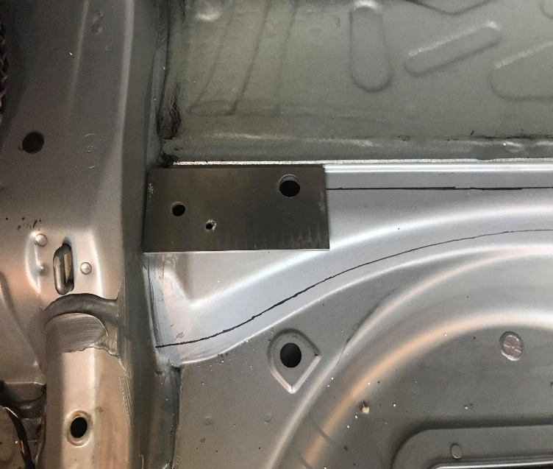 | Image 2  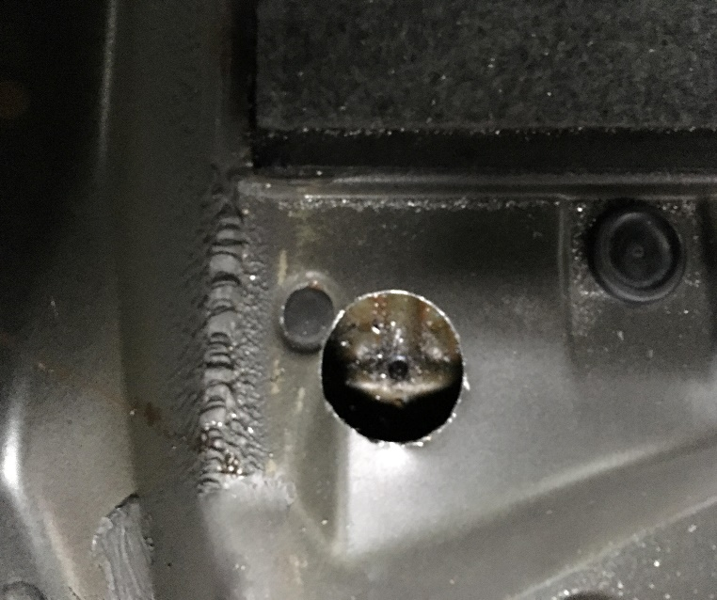
Image 3  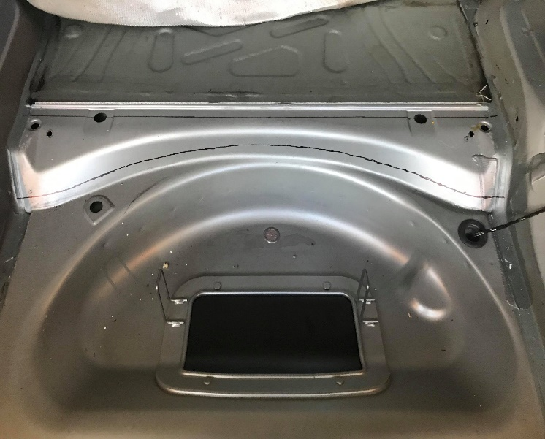 | Image 4  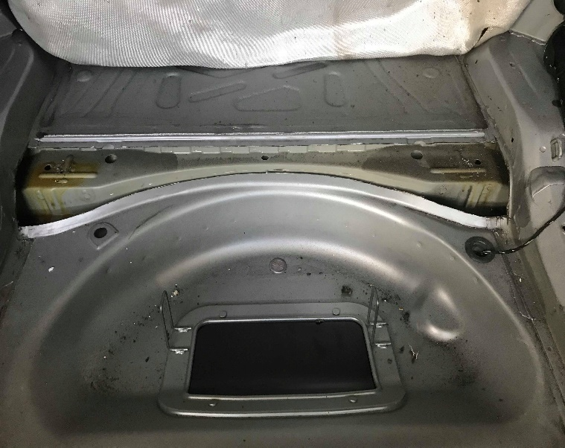
Image 5  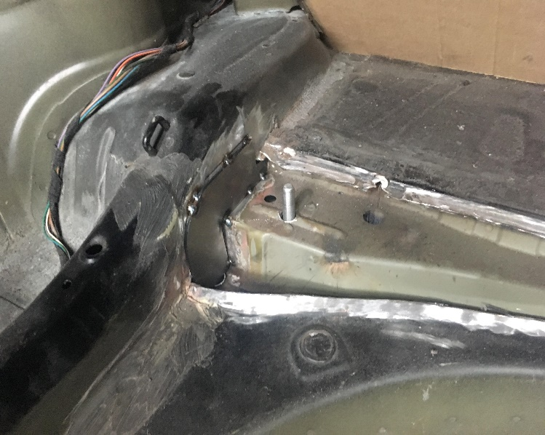 | Image 6  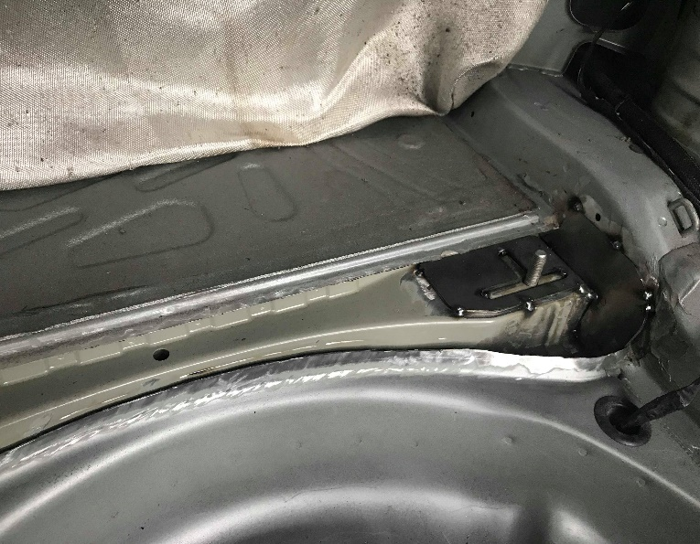
Image 7  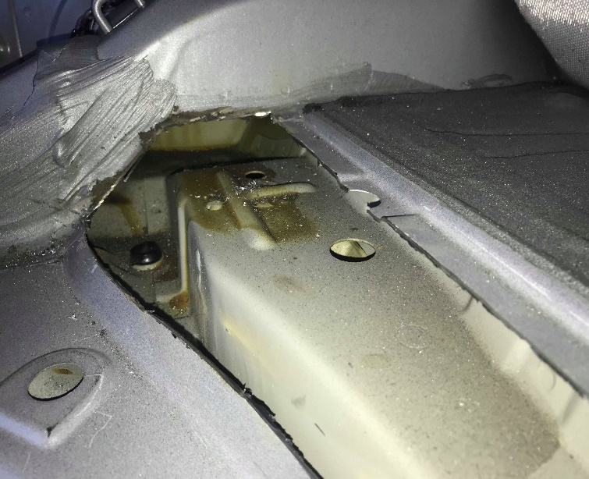 | Image 8  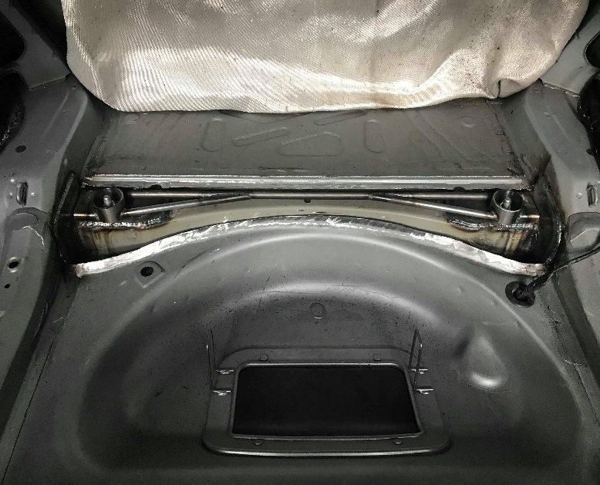
Image 9  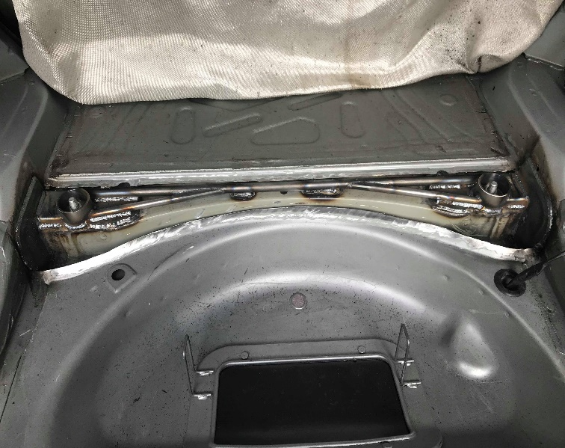 | Image 10  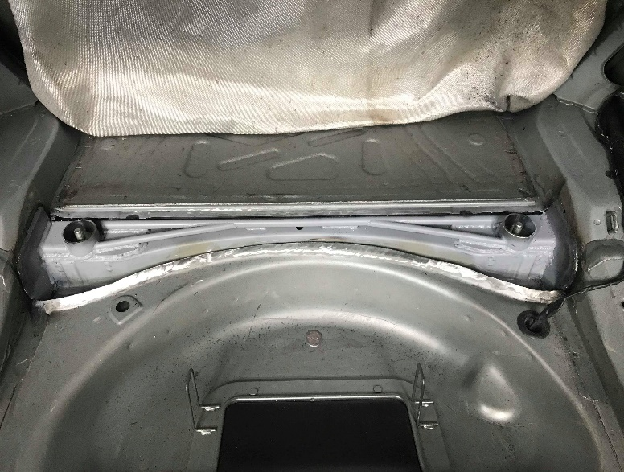
Image 11  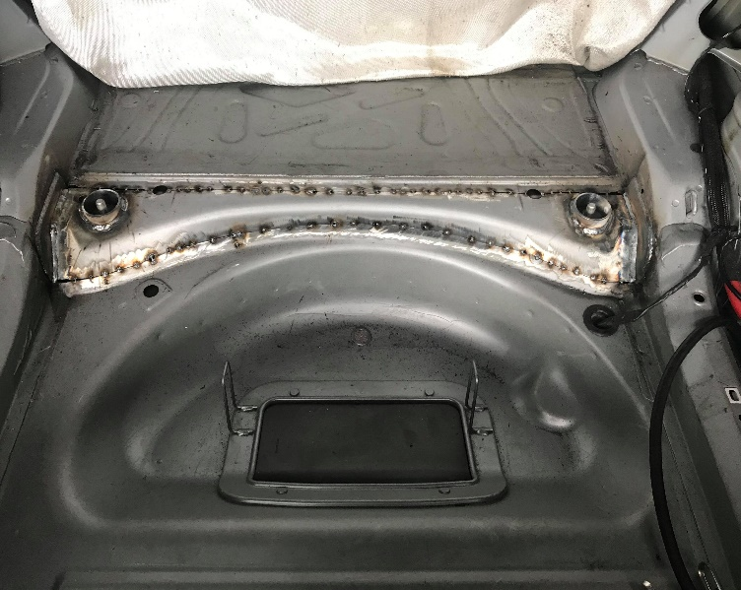 | Image 12  